# CS 340 README Template

*Use this template to complete your README file. When completing the template, keep the headings as they are so that your document has a clear organization. Remove the italicized prompt text after you have completed each section for a polished final document.*

## About the Project/Project Title

*This project allows users to create, read, update, and delete animals stored in the database.*

## Motivation

*The motivation behind the project is making the database easy to access and navigate.*

## Getting Started

*-start mongo in linux terminal*

*-import the aac_shelter_outcomes csv file*

*-create a user to be authenticated*

*-run the program*

## Installation

## *Python and mongo*

## Usage

*Use this space to show useful examples of how your project works and how it can be used. Be sure to include examples of your code, tests, and screenshots.*

### Code Example

The code imports the database using mongoimport.

The code authenticates a user to access the data.

The code lets a user add an animal to the database by entering the correct fields. There is feedback whether the user enters a valid animal or not.

The code lets a user update an animal from the database. There is feedback whether the user updates the animal correctly or not.

The code lets a user delete an animal from the database. There is feedback whether the user successfully deletes an animal or not.

The code displays an interactive dashboard showing the Grazioso Salvare Logo

The code has dashboard filtering options for queries

### Tests

*When a user adds an animal successfully the program will output “True”. If not, the program will output false.*

*When a user updates an animal successfully the program will output “True”. If not, the program will output false.*

*When a user deletes an animal successfully the program will output “True”. If not, the program will output false.*

### Screenshots

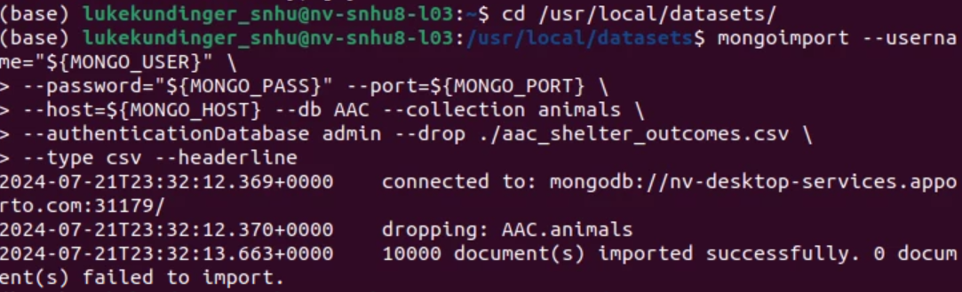  
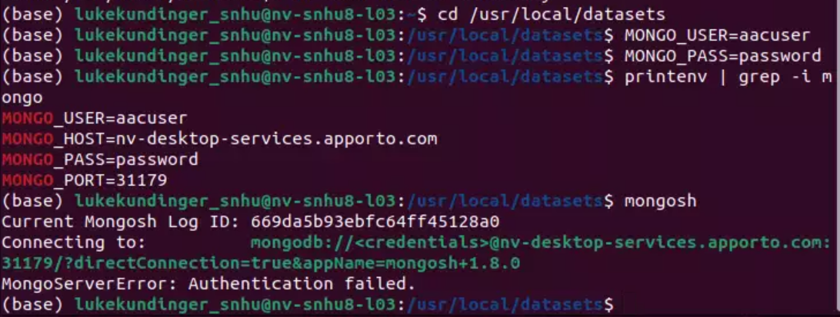

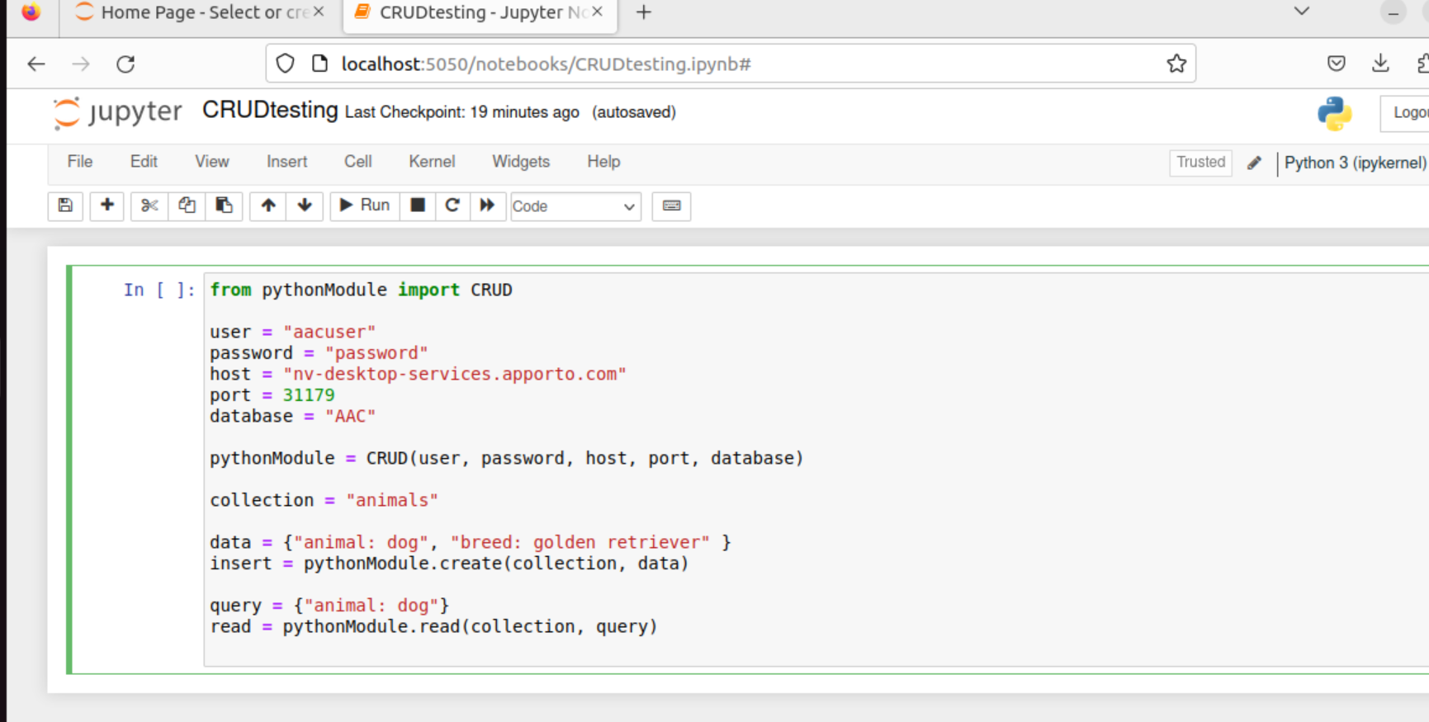

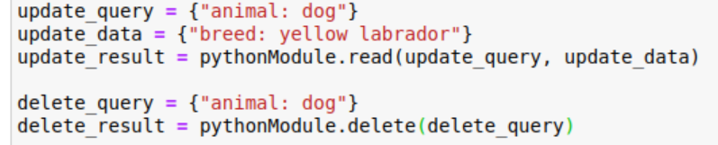

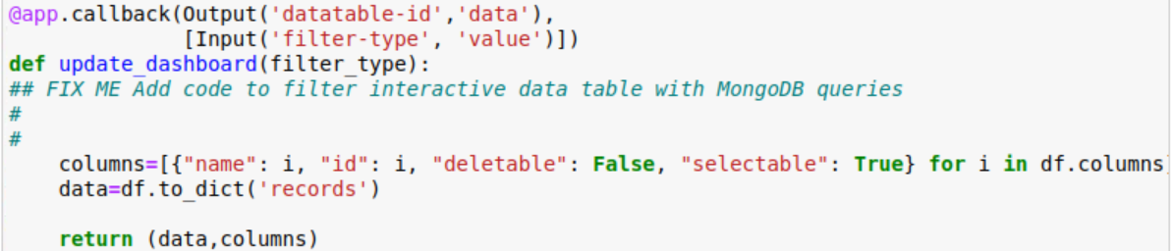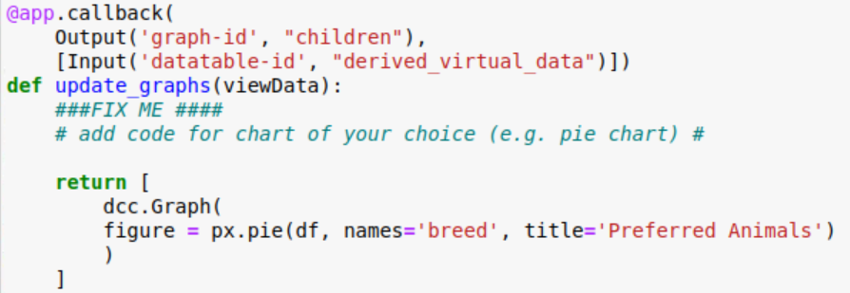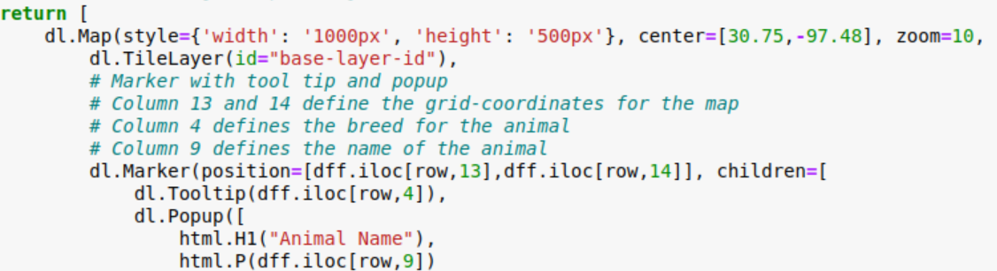

## Contact

Luke Kundinger